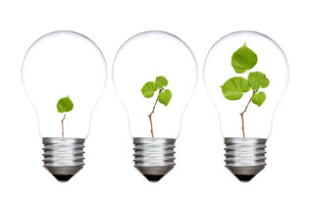
What is positive psychology?
Positive psychology is the scientific study of human flourishing, and shifts the stereotypical focus from mental health problems to the promotion of wellbeing, and creating a satisfying life filled with meaning, pleasure, engagement, positive relationships and accomplishment. Positive psychology is a relatively new branch, diverting from the traditional focuses on mental health issues.
Martin Seligman, the founder of positive psychology, stated that positive psychology should be as focused on a person’s strengths as with weaknesses and should be just as concerned with building strengths as with repairing weaknesses. He also said it should be as concerned with making the lives of normal people more fulfilling and with nurturing high talent, as with healing pathology. By creating a “happiness test”, in which anyone could measure their positive emotions, Seligman and his colleagues discovered that they could find the causation of these positive states. These were the relationships between left hemispheric activity and right hemispheric activity. When asking people who were extremely happy how they differ from the rest of society, Seligman found that the one way they
Positive Psychology
differed was that they were extremely social.
Seligman’s mission for psychology is “in addition to making miserable less miserable, is can psychology actually make people happier”.

Seligman’s 3 types of lives:
Martin Seligman believes in three different types of happy lives; the pleasant life, the engagement life, and the meaningful life.
He has defined the pleasant life as “having as many of the pleasures as you can, as much positive emotion as you can, and learning the skills (savouring, mindfulness) that amplify them, that stretch them over time and space.” This life though has some main drawbacks, one being that about 50% of a person’s positive emotions are hereditable and therefore not very malleable. The second drawback is that positive emotion habituates rapidly, and certain things can wear off.
The engagement life is a life in your work, parenting, love and leisure, and in which time seems to stop for you in moments of flow. Seligman has said that the recipe for a happy engagement life, is determining your strengths, and then recrafting your work, love and play life to use these strengths as much as possible.
The final type of life is the meaning life. Similar to the engagement life, “it consists of knowing what your highest strengths are, and using them to belong to and in the service of something larger than you are.” (Martin Seligman 2004)

Can things change the three lives?
Martin Seligman determined the answer to this as yes they can. He performed rigorous tests, the same type that are used to test what drugs work. These tests were random, placebo-controlled, long-term studies of different interventions, and how these interventions affected the overall lives of people. An examples of these interventions were to get a person take the mindfulness and savouring skills associated with positive psychology, and design a beautiful day for oneself.
Another example Seligman used was a gratitude visit; whereby a person would close their eyes and remember something someone did for them that changed their life in a good direction, and who they never properly thanked. They then had to write a 300-word testimonial to that person showing their gratitude for the actions, go to their house, and read the testimonial to them. After this test, Seligman found that when those people were tested, they were happier and less depressed.
The final example is a strengths date, in which couples identify their highest strengths (on a strengths test) and then design an evening where they both use their strengths. This showed to be a strengthened in relationships

Strategies and techniques:
Positive psychology was also defined by Gable and Haidt (2005) as “the study of the conditions and processes that contribute to the flourishing or optimal functioning of people, groups, and institutions. Scientific research has determined some strategies and skills that aid people in enjoying life to the maximum.

Enhancing:
Enhancing pleasure is one main category positive psychology focuses on. A strategy of this is savouring, which is the awareness of pleasure and giving deliberate conscious attention to the experience of pleasure. Some techniques to promote savouring are:
- Share your pleasurable experiences with others.
- Build memories of experiences, possibly by taking mental photographs or taking a physical souvenir.
- Congratulate yourself for getting to that point.
- Focus on certain elements and perceptions, closing eyes and listening to music for instance.
- Allow yourself to be completely immersed in the experience.
For positive psychology to work to its full extent, it is advised to avoid forming habits, as pleasure cannot be gained as greatly when a certain thing is repeated rapidly. Out neurons are wired to respond to new experiences, rather than experiences where no new information can be gained. Seeking out new experiences, and surprising yourself with new pleasures are techniques to enhance overall pleasure.

Engagement:
Another area positive psychology directs its focus is engagement; how you engage with both yourself and others. Mindfulness is focused on in this category. When paying mindful attention to the present, we are able to focus our perspectives and sharpen our experiences of present moments. Meditation and mindful attention training are strategies to help strengthen one’s mindfulness.
Nurturing relationships is important with regards to engagement. One of the strongest findings positive psychology has found is that strong personal relationships have a far greater impact on a person’s life satisfaction than income level can have. Positive psychologists strongly encourage spending valuable time and energy with family and friends and investing in your relationships.
Knowing your own strengths is an essential component of positive psychology. Identifying and using strengths includes thinking about how your personal strengths can be utilised in everyday life. It is important to identify whether you may be a team leader, if you love learning etc. Use these strengths in work, family and leisure time.
Psychologist Mihaly Csikszentmihayli developed the concept of flow and seeking out ‘flow’ experiences. This describes a state of joy, creativity and total involvement that can lead to a person’s happiness. Sport, games, art and hobbies are said to induce the translucence state ‘flow’ refers to. Csikszentmihayli identified ‘flow’ consists of:
- A challenging and skill-requiring task
- Concentration is used
- Clear goals are set
- Immediate feedback given
- We have deep, effortless involvement
- A sense of control is felt
- A sense on oneself disappears
- Time stops

Finding Meaning:
Keeping a gratitude diary is a strategy encouraged to find meaning in life. Writing down three things a day that made the day a bit better, and why, boosts psychological well-being levels. This can also increase these levels for lasting periods of time, rather than just short-term.
Another strategy for finding meaning is to thank a mentor. Writing a thank-you letter and reading it out to someone you owe gratitude, for instance a teacher or parent, will make someone measurably happier for more than a month.
Learning to forgive results in much less persistent rumination in a person. A simple letter of forgiveness for someone who has done wrong to you results in a release of anger and resentment, and a healthier state of being.
Reflecting on your life is very important to pursue a pleasurable life. Weighing up your life can be done by occasionally taking small amounts of time out of your day to consider how major parts of your life are tracking, like work, family and relationships.
The final strategy of positive psychology is performing small acts of kindness, which enhances connection with others, and makes you feel good about yourself. Five kind acts a week boosts psychological levels and well-being.

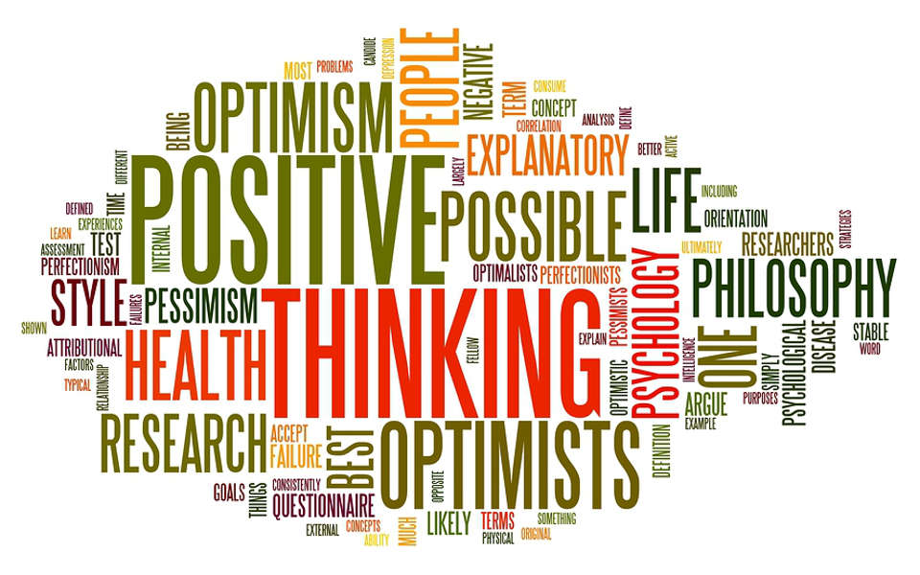
Conclusion:
Positive psychology aims to improve the lives of all people and induce a more pleasurable experience, not just for people with mental health issues, but all normal people. By focusing on strengths, rather than weaknesses, this type of psychology is revolutionary in the field, bringing to light the importance of living one’s life to the fullest. It is important to use one’s strengths as a way to benefit and enhance living.

By Matilda Mills

References:
Black Dog Institute: https://www.blackdoginstitute.org.au/docs/default-source/factsheets/positivepsychology.pdf?sfvrsn=2
Positive Psychology Institute: http://www.positivepsychologyinstitute.com.au/what_is_positive_psychology.html
Martin Segilam TED talk: https://www.ted.com/talks/martin_seligman_on_the_state_of_psychology/transcript#t-967047

